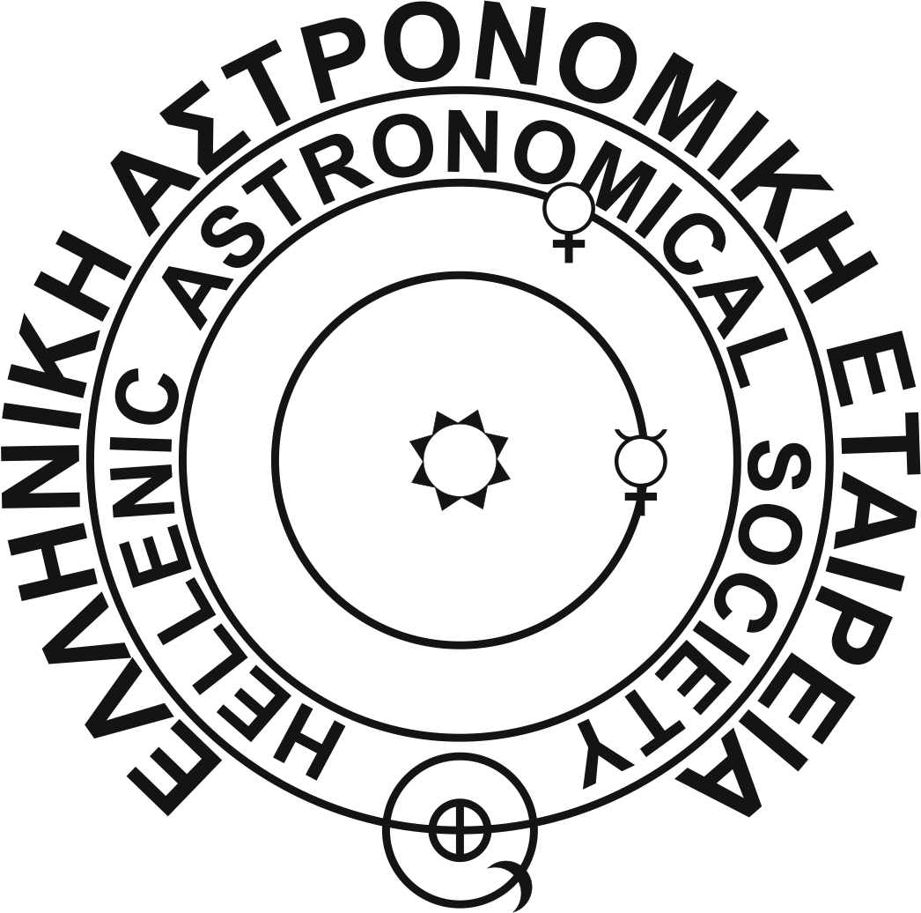
HELLENIC ASTRONOMICAL SOCIETY (HEL.A.S.)
Affiliated member of the European Astronomical Society

CALL FOR CANDIDATES
FOR THE GOVERNING COUNCIL
OF HEL.A.S. 2022-2024

Please complete the following information clearly. To nominate more candidates, you may use copies of the present form. If you send this form by email (strongly recommended) you may also sign it electronically using your digital signature.

Candidate for President
Candidate's full Name and Address:____________________________________________________________________________________________________________________________________________________________________________________________________________________________
Full Name and Signature of Proposer:_____________________________________________________

Candidates for Members of the Governing Council
(a) Candidate's full Name and Address:__________________________________________________________________________________________________________________________________________________________________________________________________________________________
(b) Candidate's full Name and Address:____________________________________________________
______________________________________________________________________________________________________________________________________________________________________
Full Name and Signature of Proposer:_____________________________________________________

Candidates for Auditors
(a) Candidate's full Name and Address:__________________________________________________________________________________________________________________________________________________________________________________________________________________________
(b) Candidate's full Name and Address:__________________________________________________________________________________________________________________________________________________________________________________________________________________________
Full Name and Signature of Proposer:_____________________________________________________

Nominations for Candidates should arrive to the Secretary of HelAS by February 28, 2022 preferably by e-mail to the address: secretary@helas.gr
One may also send them by post to the following address:
Dr. Costis Gontikakis, RCAAM of the Academy of Athens, 4 Soranou Efesiou Street, 11527 Athens, Fax: +30 210 6597602,

